# CS 340 README Template

## About the Project/Project Title

This project is a python based interactive dashboard that uses MongoDB and a CRUD module. It allows users to filter, visualize, and geolocate animals available for search and rescue training from the austin animal center dataset. It’s built using the dash framework and deployed via Jupyter.

## Motivation

The motivation for this project stems from coursework for CS-340 Client/Server Development. It uses the CRUD module from previous assignments and builds upon them.

## Getting Started

To get a local copy up and running, follow these simple steps:

* Setup a MongoDB instance and import the AAC dataset
* Clone this repository
* Edit the connection credentials listed in the Python file to match your own
* Run the file in Jupyter to use the dashboard

## Installation

Things needed to utilize this project:

* Python 3
* MongoDB
* PyMongo
* Jupyter Notebook
* Dash
* Dash-leaflet
* Pandas
* Plotly

## Usage

### Code Example

Filter buttons to view animals by type

Pie chart showing breed distribution

Geolocation map showing where selected animals are located

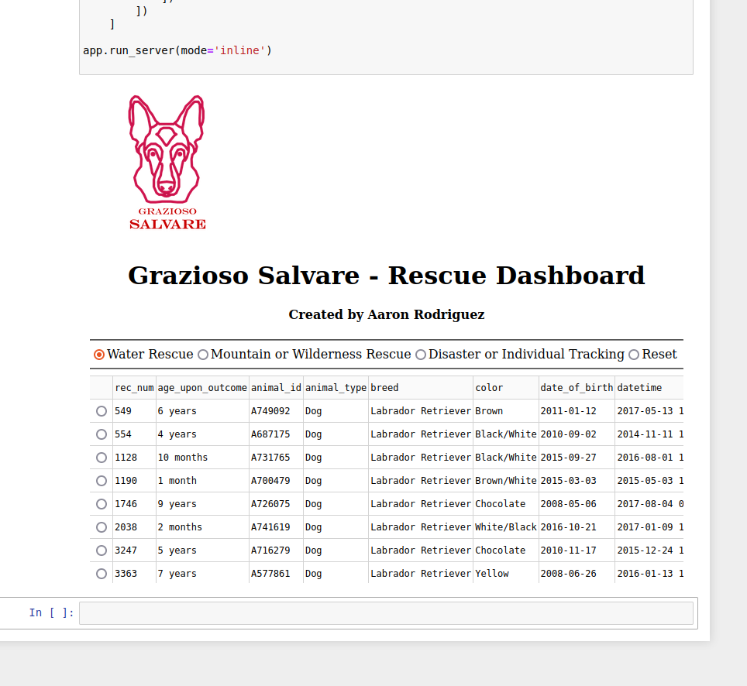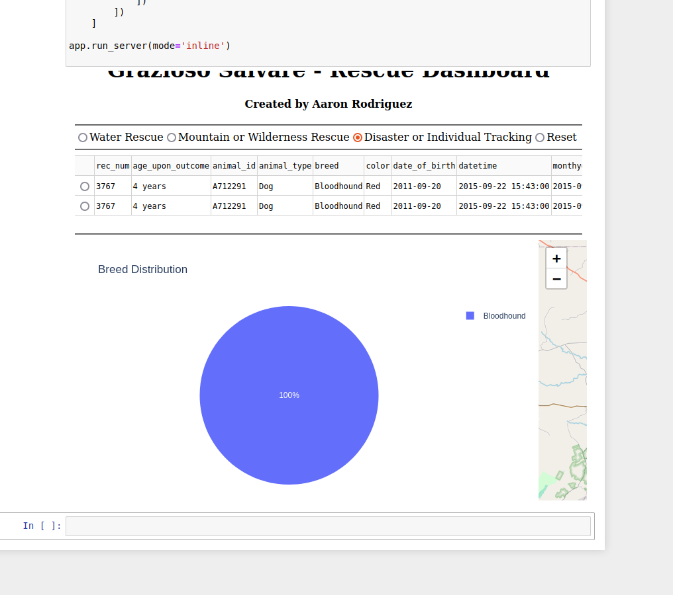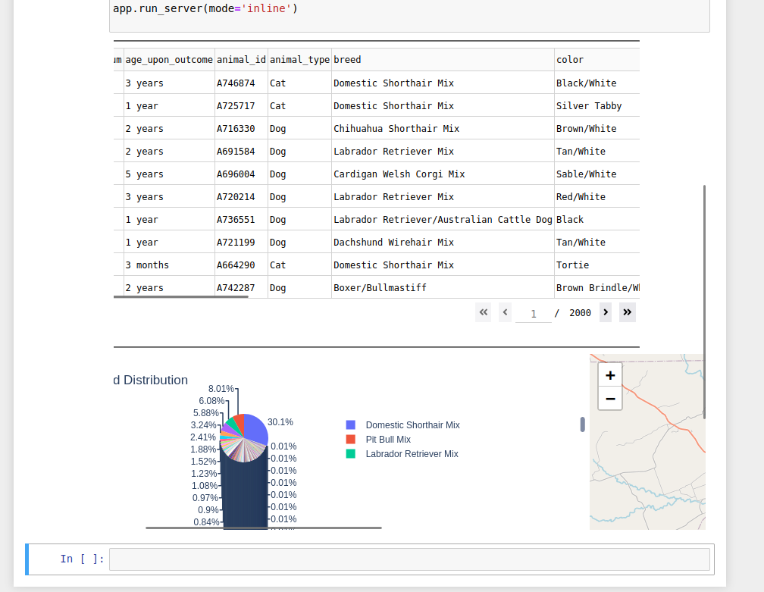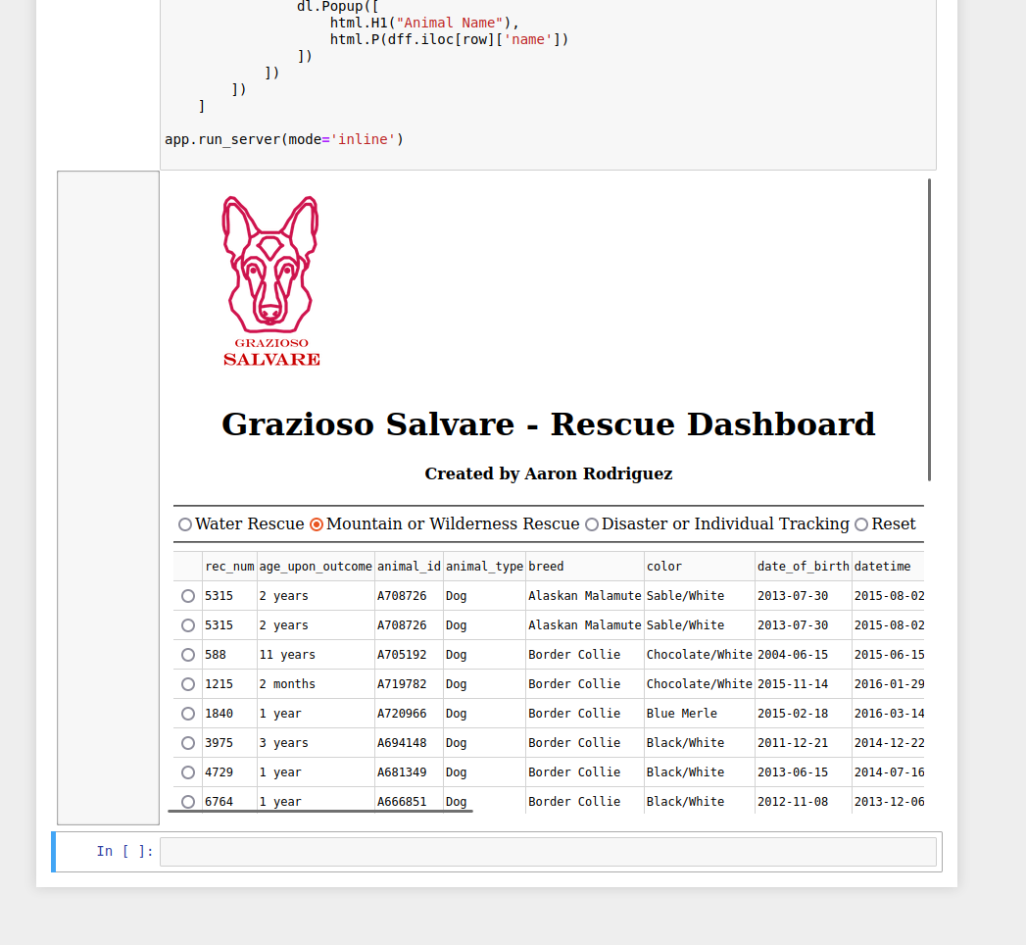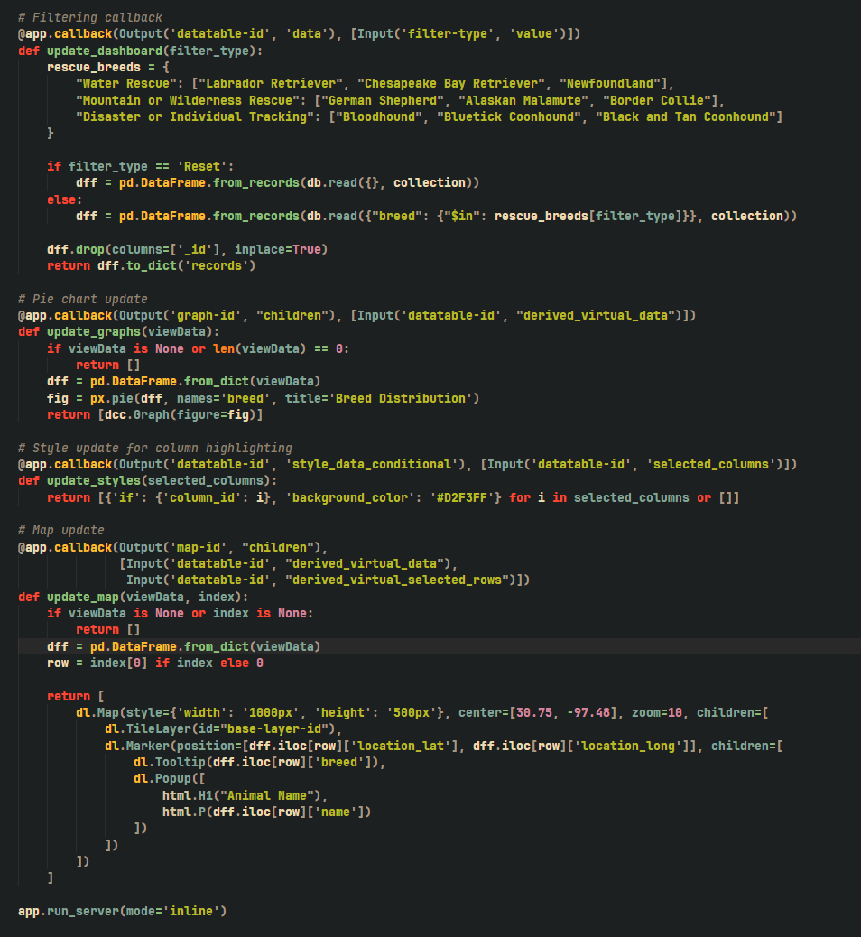

### Tests

Loose example on how to query for cats:

Db.animals.find({“animal_type”: “Cat”})

## Contact

Your name: Aaron Rodriguez II